Subjective test affidability
aaaa

[zach2019]
For both the ACR (Absolute Category Rating) and DCR (Degradation Category Rating) conventional parametric statistical analysis may be applied. However, it should be observed that many ITU-T P.800 LOT are performed without the use of a factorial independent variable design. Many such tests are performed with 36 or 48 conditions that may be widely varying in characteristics. This can be well justified, as it allows for the very efficient evaluation of many characteristics but does not allow for a full range of parametric statistical analyses that are dependent on a factorial experimental design (e.g. analysis of variance). In such cases, the analysis may be comprised of calculation of means and 95% confidence intervals (averaged over the talker samples), with t-tests to establish the degree of significant between means. Guidance on the common practices are outlined in ITU-T (2011). The CCR method on the other hand does require careful data conversion since the scale is bi-directional, compared to the hidden reference. Once data is transformed according to the randomization, parametric tests may be applied.
If the listener has correctly identified the system under test, the t-test will reject the null-hypothesis - that the listeners, across samples, was not able to detect the system(s) under test.
The data set from an MS-IPM test provides a range of options for analysis. Fundamentally the analysis of the MS-IPM is similar to most mixed methods with consensus attribute data, as presented in Section 5.6.1. The overall quality data can be evaluated using common univariate analysis techniques (means, 95% confidence intervals, t-tests, ANOVA, etc.).

[zach2019]
Statistical analysis procedures, that is, the way to extract, in the best possible way, the information from the experimental data at hand is our focus here[zach2019].
(…) Generally, a statistical analysis will include the following steps and you may have to carry out several iterations:
- Exploratory analysis (descriptive statistics).
Getting an initial idea of the important structures within the data and clarifying the basic (meta) settings of the data at hand with respect to (independent) variables and scales (dependent variables) used. Simple summary/descriptive statistics, and one- and two-variable graphics such as scatter plots and box plots.
- Modelling.
Formal identification of the overall important structures in the data set through statistical modelling, including hypothesis testing: Noise (random) effects as well as systematic (fixed) effects modelled through the design factors and covariates of the experiment. Answering overall questions such as: Whether synergistic and/or antagonistic effects, also jointly known as interaction effects, play a significant and important role for the information to be extracted?
- Validation and assumptions.
Checking the standard assumptions for the models used, including e.g. assumptions of normality, homogeneity of variance and independence to the extent that they are relevant. Investigating potential outlying and influential observations.
- Conclusions, summary and final visualization of results.
Summarize the important findings by tables and visualizations. Post hoc analysis in ANOVA settings. Include model estimates, hypothesis test results and uncertainties and confidence intervals from the resulting models
A first approach to summarising experimental data and associated findings may often in- clude simple averaging and some simple variability and uncertainty judgements.
………
………….
………..
……….

[borwick2001]

For what concerns rating scales as the experimental method used…
They enable the listeners’ opinions to be transformed into numerical data that through statistical analysis can examine possible psychoacoustic relationships between the stimulus and its perception. The scale of choice is appropriately defined for the attribute(s) being measured. Its meaning should be clearly understood by the listeners so that it is used in a consistent fashion. (…) In particular interval scales such as the 0-10 Fidelity scale and Preference Scale (or the variation on the latter called “bi-polar Reference scale” including a reference or anchor product to establish consistency in the use of the scale). Attaching meaningful verbal attributes to the intervals or the end-points will help ensure consistent interpretation and use of the scale.
The major problem with using interval scales is that we may find some listeners will interpret and use the scale differently, which can cause scatters and outliers in the data. Normalizing the data can make visualization of any trends more apparent.
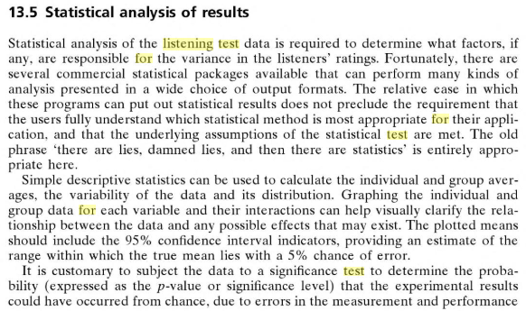
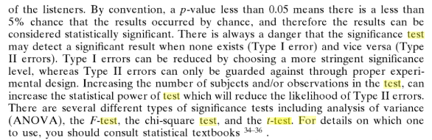
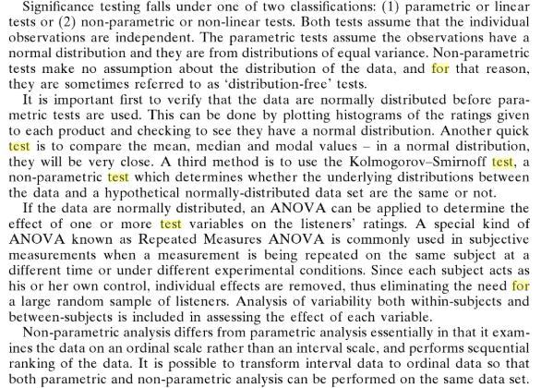
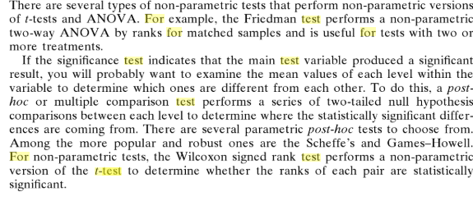
A listener’s performance can be quantitatively measured by statistically analysing their listening test data. By performing analysis of variance (ANOVA) on each individual listener’s data, the error variance and F-statistic scores can be computed to establish who are the most discriminating and reliable judges of sound quality.

[bech2006][bech_zach_tutorial]
There are two basic aspects that need to be considered when applying a direct scaling technique. The first is the properties of the numbers that the subjects have assigned to the stimuli. The second aspect is the method that has been used to obtain the numbers. These two aspects are not independent as certain methods tend to dictate the properties of the numbers. Four different categories of measurement scales are normally considered in accordance with the suggestions of Stevens (see Nunnally and Bernstein [328]:
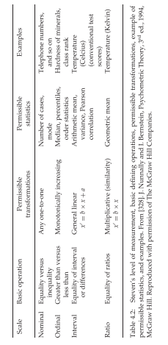
(…) Stevens suggested that the type and degree of statistical analysis was linked to the scale type as indicated in Table 4.2 in the column ‘permissible statistics’. Data based on nominal and ordinal scales should be analyzed using methods based on, for example, the binomial distribution (frequencies for nominal scales and ranking for ordinal measurements). Interval- and ratio-based data could be analyzed using quantitative analysis methods based on an assumption of a normal distribution (t-test and ANOVA).
A more pragmatic view that is preferred by the authors and recommended, for example, by the ITU-R Recommendation BS.1116- 1 (guarda sotto) is that data based on an–assumed–interval scale is analyzed by quantitative statistics unless severe violations of the scale properties or statistical assumptions are present, in which case it is re-analyzed using categorial based methods. The two sets of results can then be compared and valid conclusions made.
(…) more detailed discussion of statistical analysis of data including a description of the various statistical procedures available for categorial and quantitative data is found in Section 6.2
(…) One of the main purposes of statistical analysis is to estimate how general the results of the experiment are. Ideally, the conclusions of an experiment based on a limited sample of the population (loudspeakers, programmes, subjects, etc.) should be valid for the population in general.
PRIMA
Section 6.1
The basic purpose of a listening test is to objectively quantify the variations in auditory impression caused by the presented stimuli. Here comes:
THE BASIC STATISTICAL QUESTION [bech_zach_tutorial]
Is the observed variability in the subjective impression a result of the presented stimuli (e.g. loudspeaker–programme combinations) or is it random fluctuations ?
YES: There are, statistically significant, audible differences between some of the presented loudspeaker‐programme combinations
NO: There are no, statistically significant, audible differences between the loudspeaker‐programme combinations
The statistical analysis is based on the assumption that the t, ith score (UNIVARIATE), Yt,i provided by a subject consists of two parts: one part $μ_{t}$ representing the reaction to the ith repetition of the stimuli t defined by the controlled experimental variables (the treatments) and the other, an error part representing a random variation caused by a range of uncontrolled variables:
$$Y_{t,i}=μ_{t}+∈_{t,i}$$
The random variation caused by uncontrolled variables is related to the subject themselves and/or the experimental set-up and environment. The variables related to the subject are physiological variables such as variations in sensitivity, background level of intrinsic neural activity, and so on, and cognitive variables such as mood, expectation, interpretation and bias effects (see Section 4.2.4).
The model describing a subject’s score can be further elaborated as the mean $μ_{t}$ can be divided into an overall mean $μ$ representing the mean of all treatments in the experiment plus a treatment effect $α_{t}$ corresponding to a specific treatment t.
So, the statistical model for the observed t,i^{th} score from a subject is obtained:
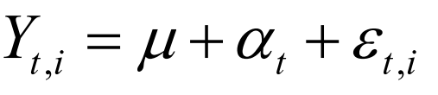
The experimental error is often assumed to be normally distributed N(0, $σ^{2}$).
(division of variables in experimental research)
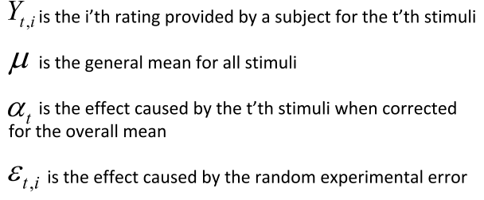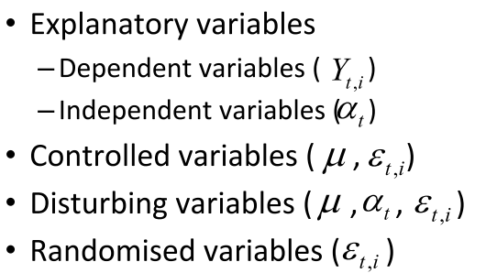
______
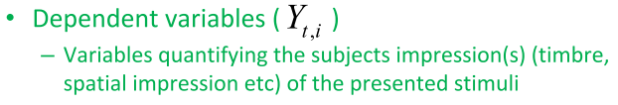
This is the response(s) provided by the subject (see Chapter 4 for further details)
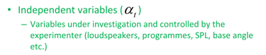
examples of qualitative would be ‘Loudspeaker’ with five levels (i.e. five different loudspeakers) or ‘Programme’ with four levels (i.e. four different programme sections)
examples of quantitative variables would be repro- duction level in sound pressure level (SPL) (dB) or base angle (degrees) in a stereophonic set-up. See Chapter 5 for a more detailed discussion of the independent variables
____
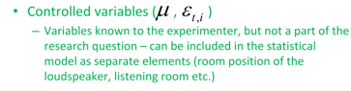
Example: subject’s fatigue, the position of the loudspeaker in the room, equalisation of loudness, and so on. Some of these are typically held at a constant level (e.g. the experiment is conducted ‘blind’, loudness differences are equalised and the room temperature is held constant) and are therefore not a specific part of the statistical planning.
__
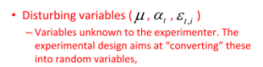
These are uncontrolled (unknown) variables that can or will be confounded with the explanatory variables. It is oneof themajor tasks of the experimental design to eithermove these variables into being controllable or apply a randomisation scheme that will break any systematic relationship between them and the independent variables
_____
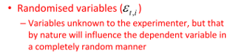
$→$E NEL DESIGN DEI TEST SI E’ TENUTO CONTO DI TREATMENT DESIGN ECC…
Is the variation in the subjective impression introduced by the controlled variables, sufficiently large compared to the random variation (error) to be able to conclude that the controlled variables have a real influence on the impression?
Another purpose of the statistical analysis is to provide an estimate of how generalisable the conclusions are.
One of the main purposes of statistical analysis is to estimate how general the results of the experiment are. Ideally, the conclusions of an experiment based on a limited sample of the population (loudspeak- ers, programmes, subjects, etc.) should be valid for the population in general.
(Pagg. 157 – 161)
(…) Once the experimenter has decided on a treatment design, determined the number of observations per stimuli, and designed the allocation of stimuli to the subjects, the experiment is, statistically speaking, ready for execution DONE
After collecting the observations, the statistical analysis is performed, on the basis of which the conclusion to either accept or reject $H_{0}$ will be made. The next section discusses the statistical analysis of observations.
(Pag. 161) Section 6.2
Before conducting the statistical analysis, the type or properties of the collected data should be considered. Data fall into two categories, namely, quantitative and categorical data. Quantitative data reflects a continuous quantity or the degree of a given property, and an example would be ratings reported on interval scales (or scales that are assumed to have interval properties). Such data are usually normally distributed and analyzed using the standard t-test, ANOVA, and so on, and this class of methods are often referred to as parametric statistics. Categorical data are based on categorical scales such as ‘prefer’ versus ‘not prefer’ or ranks like the 9-point hedonic scale, and they are often binomially or chi-squared distributed. The statistical techniques used to analyse such data are often referred to as non-parametric statistics. However, when seen from a purely statistical point of view, such a division of the statistical methods does not make sense as many of the so-called parametric methods can also be used to analyse categorial data and non-parametric methods can be used to analyse quantitative data as well.
for the basic analysis of data it is still of importance to know whether the data must be considered as quantitative or categorical, BUT, responses based on interval scales including 11 or more levels could be analysed by parametric procedures provided the statistical assumptions are not violated severely.
the question is when can data from an assumed interval scale be considered continuous?
This means that results based on the 10-point fidelity scale and 5-point impairment scale, both of which have a one decimal place resolution leading to 100- and 50-point scales, respectively, could be analysed using parametric statistics.
$→$ PER NOI ADDIRITTURA IL VALORE E’ CONTINUO (con errore sulla minima
discretizzazione dello slider)
The 10- and 5-point rating scales are those that are most frequently applied in listening tests, so the following chapters will be more focused on parametric methods than categorical methods
A typical situation is that the experimenter wishes to examine the influence of a set of independent variables on the dependent variable (e.g. the subject’s impression of sound quality). In this case, the so-called dependence techniques must be applied.
(however, readers interested in interdependence techniques such as principal components analysis (PCA), multidi- mensional scaling (MDS) and factor analysis (FA) …)
The main purpose of most listening tests is to explore the relationship between a number of independent variables and a single dependent variable.
$↑$ The typical situation is that the relationship between the dependent and independent variables is analysed for each dependent variable separately. This calls for the so-called univariate analysis methods such as standard ANOVA and regression analysis.
However, if, for example, the dependent variables belong to the same group of variables (e.g. spatial impression) and thus, logically, could interact, they must be analysed together and the so-called multivariate techniques need to be applied. Most listening tests will only ask the subject a single question, so the univariate analysis technique is most frequently applied, and the following text will thus be primarily focused on this technique.
(DA PAG. 164)
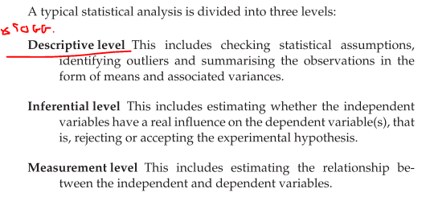
The descriptive and inferential levels are the most relevant for analysis of results from listening tests. The measurement level is used only at a later stage of the analysis when, for example, the relationship between the subjective impression and physical measures is investi- gated.
• 6.2.3 DESCRIPTIVE LEVEL: The purpose of the analysis at this level is to obtain an overview of the collected data
checking the statistical assumptions, identifying outliers and summarising the observations in the form of mean values and associated variances
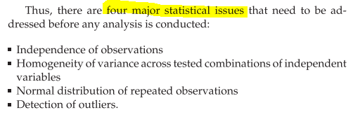
To use the ANOVA test we made the following assumptions:
*All samples are drawn independently of each other
*All populations have a common variance
*Each group sample is drawn from a normally distributed population
*Within each sample, the observations are sampled randomly and independently of each other
*Factor effects are additive))))

1. INDEPENDENCE OF OBSERVATION controlled by means of statistical experimental design
2. HOMOGENEITY OF VARIANCE ACROSS TESTED COMBINATIONS OF INDEPENDENT VARIABLES
This means that the population variances in each group are equal.
$→$ Keppel and Wickens [253], in Section 7.4 of their book, discuss a number of different tests and possible transformations of the data if the assumption is not met.
$→$ spread-versus-level plot, where the spread per cell is plotted against the tested combinations (levels) of the independent variables (see for example Figure 6.15).
The homogeneity of the variance of the residuals can be checked by visual inspection of plots of observed versus expected residuals and observed residuals versus variable levels.
USE BARTLETT AND LEVENE WITH MATLAB!
REMEMBER: The low p-value, p = 0, indicates that vartestn rejects the null hypothesis that the variances are equal across all five columns, in favor of the alternative hypothesis that at least one column has a different variance.
[https://it.mathworks.com/help/stats/vartestn.html#btuo7w_]
$→$ ANOVA ROBUSTNESS IN VIOLATION OF IT
Moderate deviations from the assumption of equal variances do not seriously affect the results in the ANOVA. Therefore, the ANOVA is robust to small deviations from the HOV assumption. We only need to be concerned about large deviations from the HOV assumption
[http://www.math.montana.edu/jobo/st541/sec2e.pdf]
3. NORMAL DISTRIBUTION OF REPEATED OBSERVATION normality assumption is related to repeated observations for combinations of the independent variables, not across the independent variables themselves.
The distribution of the original data, for say a group of four loudspeakers, will be determined by the four mean values and can or should not be normally distributed, but the repeated ratings for each loudspeaker should be.
IN OTHER WORDS: The dependent variable is normally distributed in each group that is being compared in the one-way ANOVA (technically, it is the residuals that need to be normally distributed, but the results will be the same).
should preferably be performed both graphically
- Review the distribution graphically (via histograms, boxplots, QQ plots)
- Analyze the skewness and kurtosis
and statistically
$→$A number of statistical tests exist for testing the deviations from normality:
- Kolmogorov–Smirnov
- Shapiro–Wilk
(basically, the hypothesis is that the distribution is normal, and this can only be rejected or not)
[http://www.real-statistics.com/one-way-analysis-of-variance-anova/assumptions-anova/]
$→$ NORMALITY ASSUMPTION (Shapiro-Wilk has good power in fairly small samples)
https://stats.stackexchange.com/questions/324795/normality-test-on-small-samples
So, when testing for normality works in the opposite “usual” statistical test!
Probabilities > 0.05 mean the data are normal.
Probabilities < 0.05 mean the data are NOT normal.
This is because… typically, we are interested in finding a difference between groups. When we are, we ‘look’ for small probabilities. If the probability of finding an event is rare (less than 5%) and we actually find it, that is of interest. When testing normality, we are not ‘looking’ for a difference. • In effect, we want our data set to be NO DIFFERENT than normal. We want to accept the null hypothesis.
[http://webspace.ship.edu/pgmarr/Geo441/Lectures/Lec%205%20-%20Normality%20Testing.pdf]
[https://stats.stackexchange.com/questions/324795/normality-test-on-small-samples]
• check other tests for comparison
$→$ ANOVA ROBUSTNESS IN VIOLATION OF IT
[https://statistics.laerd.com/statistical-guides/one-way-anova-statistical-guide-3.php]
The one-way ANOVA is considered a robust test against the normality assumption. This means that it tolerates violations to its normality assumption rather well. As regards the normality of group data, the one-way ANOVA can tolerate data that is non-normal (skewed or kurtotic distributions) with only a small effect on the Type I error rate.
However, platykurtosis (a platykurtic distribution has "lighter tails" than a normal distribution, that is, few, if any, values at the extreme ends of the curve) can have a profound effect when your group sizes are small.
[https://stats.stackexchange.com/questions/5680/can-i-trust-anova-results-for-a-non-normally-distributed-dv]
Like other parametric tests, the analysis of variance assumes that the data fit the normal distribution. If your measurement variable is not normally distributed, you may be increasing your chance of a false positive result if you analyze the data with an anova or other test that assumes normality. Fortunately, an anova is not very sensitive to moderate deviations from normality; simulation studies, using a variety of non-normal distributions, have shown that the false positive rate is not affected very much by this violation of the assumption (Glass et al. 1972, Harwell et al. 1992, Lix et al. 1996). This is because when you take a large number of random samples from a population, the means of those samples are approximately normally distributed even when the population is not normal.
che però non è il nostro caso perchè il dataset è piccolo

4. DETECTION OF OUTLIERS
The tradition in statistics is to label an observation ‘outlier’ if its value is higher than 2.5 times the standard deviation. This assumes a symmetrical distribution of observations, so it is rec- ommended to also use the box plot as a further aid. (CONTINUE…)
DA PAG.216 (“Test of ANOVA model assumptions”)
Aaa

• 6.2.4 INFERENTIAL LEVEL:
concluding whether the experimental variables have a significant influence on the perception reported by the subjects.
This section is divided into three parts:
1- Relationship between the true and estimated mean values
NO NEL NOSTRO CASO
2- Relationship between two estimated mean values
In listening tests, the purpose is often to compare different versions of the same loudspeaker or to benchmark against competitors. Assume that a series of listening tests have been conducted, in which ratings have been obtained for two loudspeakers for the same selection of programmes. The question is: Are the two loudspeakers significantly different or is the observed difference just due to chance?
(Parametric tests) A distribution of ratings (collected through repe- tition of the experiment), similar to that shown in Figure 6.3 (repeated assessments), exists for each loudspeaker. After
(Cathegorical tests) NO NEL NOSTRO CASO
3- Relationship between several estimated mean values.
Most listening tests include several loudspeakers and programmes. This means that the number of mean values that should potentially be compared increases quite quickly. The relationship between the number of pairs and the number of means is given by $N=\frac{n⋅\left(n-1\right)}{2}$ where N is number of pairs and n is number of mean values.
NO conduct all the necessary t-tests but
it would be advantageous if a preliminary analysis could be conducted with the aim of identifying whether any significant differences exist within the group of means. Such a test is termed an analysis of variance (ANOVA) with its associate test paradigms.
The chapter is focussed on the analysis of a so-called randomized block design with a complete factorial experiment randomised within each block. In the listening tests, such a design would have subjects as blocks and each subject would be presented with all combinations of the variables in a random order in a single session. The first example will only include one subject, so this reduces the design to a complete randomised factorial design.
CATHEGORICAL NOT DISCUSSED HERE
• (univariate)ONE VARIABLE (ONE WAY) ANOVA MODEL
(SPIEGA COSA STIAMO FACENDO) (***Leggilo sotto su “clarification and basics”)
• (univariate)ANOVA MODEL FOR MORE THAN (N-WAY) ONE VARIABLE
Listening tests are conducted using several programmes, and this introduces an additional treatment variable in the ANOVA model, accounting for the variation caused by the different programmes:
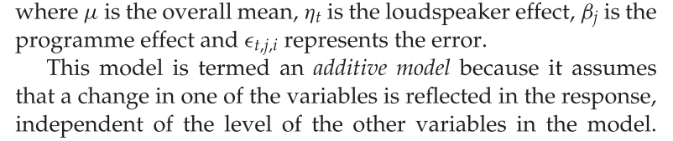
Example: five loudspeakers, four programmes, one subject and 10 repetitions
(…) it is known by experienced recording engineers, for example, that the rank order of loudspeakers with respect to sound quality can change significantly for different programme types. This means that a change in the programme variable will influence the ratings of the loudspeaker, depending on the loudspeaker. So, the rank order of the loudspeakers changes as a function of programme.
$→$ QUELLO SUCCESSO A NOI (guarda fig.6.11)
The additive model is thus not sufficient to describe the results of the experiment, and a so-called interaction variable needs to be included in the model:
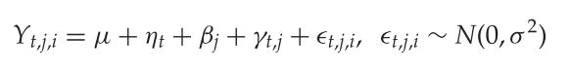
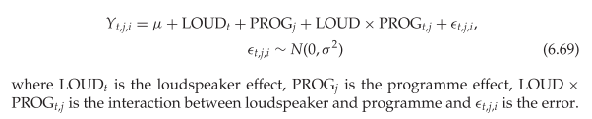
(an ANOVA model including the interaction for the t,j,i th score)
If we see the ANOVA table the interaction variable is significant??
SS_{error} has been more than halved because of the addition of the interaction term
The last addition to the ANOVA model that will be discussed in this section is the ‘subject’ variable.
One of the main assumptions of ANOVA model is the independence of observations and this was justified on the basis of the randomised presentation order. HOWEVER,
QUESTION: whether ratings (both repeated and for different stimuli) from the same subject can be assumed to be independent even for randomised presentations?
PER INTRODURRE QUESTA VARIABILITà NEL MODELLO
anzichè un solo soggetto fare tutte le valutazioni ripetute…
…
Example: 10 subjects providing one rating of each of the 20 loudspeaker and programme combinations
differences between subjects (about using the rate scale: in terms of overall mean, overall range employed and range of repeated ratings) will inflate the error variance in the ANOVA model, and the resolution of the test is lower than it would be if this variance could be removed by adding a subject variable. The ANOVA model should thus include a ‘subject’ variable that is able to take the differences between subjects into account, as well as the effects of having correlated scores from the same subject.
$→$CIO’ CHE E’ SUCCESSO EFFETTIVAMENTE NEL TEST
(Perchè altrimenti non è che conviene sempre farlo, c’è un trade-off:
the addition of a subject variable thus adds the possibility of including the interaction between the subjects and the other variables, thereby potentially further im- proving the sensitivity of the tests. However, it should be remembered that the ‘cost’ of including the additional inter- actions is a loss of degrees of freedom for the error variance, which could mean a decrease in the resolution. Thus, if the interaction variables are found not to be significant, it is recom- mended that the ANOVA model is reformulated only to include significant variables to obtain the maximum sensitivity of the F-test)
The simplest approach is thus to add ‘subject’ as a main variable plus its interactions in the ANOVA models examined so far.
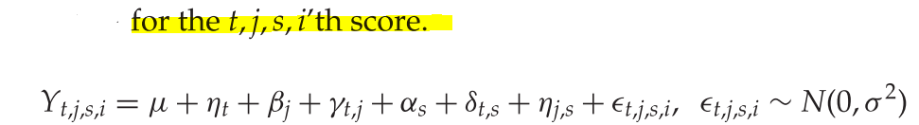
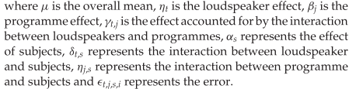
The next issue to be considered in connection with adding the subject variable is the potential for correlation between scores from the same subject.
• AAA
• AAA
aa

[itubs1116-1] APPENDIX 1 Evaluation of listener expertise (NO)
The double-blind triple-stimulus hidden-reference method provides two grades on each trial and makes it possible, on an individual subject-by-subject basis, to compare these two grades directly and to examine these comparisons across all trials for that individual. For each trial one can take the algebraic difference between the two grades for a trial, always, of course, subtracting in the same direction. Let us assume that we are subtracting the grade for hidden reference from the grade for the object. If the subject was not successful overall at correctly identifying the hidden reference versus the object, then the average of all the difference grades from that subject in the listening test would be at or close to zero, since there would be both positive and negative grades tending to balance each other out on the average. If the subject was able, overall, to detect which was the hidden reference and which the object correctly, then the average of the difference grades would deviate from zero in a negative direction, since more of the grades would be negative than positive.
IN OUR CONTEXT NO COMPARATIVE! $→$ COME APPLICARE AL NOSTRO CONTESTO?
The data thus obtained are subjected to a one-sided t-test, to assess the likelihood that the mean of the distribution for each subject is zero. If this null hypothesis is rejected for a given subject, then one may conclude that the data for that subject originates from a distribution with a mean greater than zero in a negative direction, at a given level of confidence. It may be concluded, then, that each subject for which this is true has demonstrated that he or she was not, overall, merely guessing; rather, these subjects may be said to have shown sufficient expertise to justify including their data in the final analyses of the experimental results. The data of the other subjects – those who were, overall, guessing, by this statistical criterion – can be rejected from further analysis

[Moulin2016a] Is the set of stimuli relevant?
These results indicates that the set of stimuli (combination of 5 sets of loudspeakers by 5 tracks) is relevant since it allows the discrimination of the loudspeakers under investigation, and it includes small differences that will be useful for highlighting the resolution of other test methodologies.
Moreover, the differences between loudspeakers relies on various sound charac- teristics including timbral, spatial and temporal aspects.

[interpret_statistic]
Aaa

[…] Parametric or not? GUARDA SOPRA
$→$
USE OF NONPARAMETRIC TESTS?
https://help.xlstat.com/s/article/what-is-the-difference-between-a-parametric-and-a-nonparametric-test?language=en_US
https://help.xlstat.com/s/article/which-statistical-test-should-you-use?language=en_US

[itubs1116-1]
The fundamental aim of the statistical analysis of test results is to identify accurately the average performance of each of the systems under test and the reliability of any differences among those average performance figures. The latter aspect requires estimation of the variability or variance of the results.
Provided that the assumptions underlying parametric statistics are reasonably met, then this approach provides the most sensitive and powerful one and is therefore recommended. Only if important properties of the data show severe departures from the assumptions underlying the analysis of variance (ANOVA) should alternative analysis methods (e.g. non-parametric ones) be considered. Specifically, it is recommended to apply an ANOVA model as the first stage, the primary analysis. Subsequently, other methods (such as t-test, Neuman-Keuls, Scheffe, etc.) using variance estimates provided by the ANOVA can be used to study in more detail where the significant overall effects revealed by ANOVA (if any) are to be found.
A specific hypothesis can often be validated by several different statistical methods.

CLARIFICATIONS AND BASICS (ANOVA)

[Science2010]
APPROCCIO: The absolutely simplest situation is when there is only one factor that is causing the variation, all other factors being kept constant. From this simplest situation we expand first to the situation with two factors and then to situations with several factors involved.
ANOVA comprises a large number of methods, but all of them have in common that the focus is on testing the importance of various factors on the outcome of an experiment. The main purpose of ANOVA methods is to identify and quantify the factors that are responsible for the variability of the response. In practice, this is most often achieved by first identifying which factors which are significant and then by investigating the most important factors in more detail by so-called post-hoc tests [Science 2010]

The concept of random effect and mixed models is introduced in order to make the conclusions from ANOVA of sensory and consumer data more relevant for practical purposes.
- Models for special situations
- Post hoc tests for detecting which levels of a factor that have different average values of the response will be covered at the end of the chapter
The chapter is based on the material in Chapter 12 (Statistical design of experiments(DoE)) and is the basis for
Chapters 5 and 8 $→$investigating product differences in sensory and consumer studies

Example: from chap.5
FROM CHAPTER 5 (It will be demonstrated how sensory analysis companied with ANOVA and PCA can be used for testing for sensory differences and for interpretation):
This is the case both for product development situations and for quality control. In the following we will describe typical problems and useful methodology for such situations. We will here focus on techniques related to sensory profiling. Generally speaking, for example, thinking about food, how experimental design factors affect the sensory properties of the products?
We will first focus on analysis of models with only one sensory attribute. Afterwards, these tests will be extended and generalised to the more general situation with several sensory response variables. Main attention will be given to random replicates, but some attention will also be given to alternative replicate strategies.
The methods treated in this chapter all concentrate on one attribute at a time.
EXAMPLE: CI SONO DIFFERENZE TRA QUESTI CAMPIONI DI PESCA, SE SI DETERMINATI DA QUALI FATTORI?
(J = 16) frozen pea samples. The first problem considered is whether there are differences between profiled in 3 replicates (R = 3) using 13 attributes (K = 13). (…) Mean values will, however, in practice always be different and one will usually be interested in knowing whether differences are large enough to be determined as significantly different.
In addition to having an overall assessment of the effect of a factor, one will also be interested in knowing for which level of the factor that the actual differences are. This

[itubs1534-3] [bech2006] WHY ANOVA AND NOT T-TESTS
ANOVA is the equivalent of running multiple t-tests. As a result, you'd need to run some post-hoc analysis to determine which of the individual level comparisons are significant
The test statistic in the t-test is known as the t-statistic. The t-test looks at the t-statistic, t-distribution and degrees of freedom to determine a p value (probability) that can be used to determine whether the population means differ. The t-test is one of a number of hypothesis tests. To compare three or more variables, statisticians use an analysis of variance (ANOVA). If the sample size is large, they use a z-test. Other hypothesis tests include the chi-square test and f-test.
SO…
ANOVA provides a statistical test of whether or not the means of several groups are equal, and therefore generalizes the t-test to more than two groups. As doing multiple two-sample t-tests would result in an increased chance of committing a statistical type I error
(as stated also in
[itubs1534-3]
[bech2006] (PAG.196)
).

ANOVA uses a different calculation. Its value is in looking at variation between and within the means. It not only compare the means (like the t-test) but examines the variation in calculating the means. Excessive variation in calculating a mean reduces the chance of determining a significant difference. The ANOVA test is robust to the assumption of normality

[bech2006] GOOD EXAMPLE ONE WAY ANOVA MODEL
Let us assume that a pilot-test including five loudspeakers and one programme item was con- ducted to obtain an impression of the differences in sound quality between the loudspeakers. One subject participated in the test and rated each loudspeaker 10 times in randomised order
using a single presentation paradigm:
5 speakers
1 track
1 subject like 10 different subject rating (non è che ne conto piu di uno alla votla è per differenziarmi dalla situazione dopo)
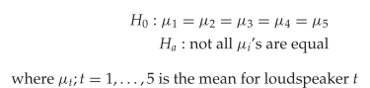
10 t-tests should be conducted according to the stated formula for the ‘paired comparisons’.
PER COME FUNZIONEREBBE IL T-TEST The paired t-test applied in the previous sections is based on the ratio of the average of difference scores and the variation of the difference scores.
$→$ VEDI codici matlab machine learning
If the ratio is large enough, it can be concluded that the observed differences are not the results of random variations and H0 is rejected.
The rationale behind the ANOVA is the same as that for the t-test: compare the deviation between the sample means of the treatments to the random deviation within the samples and test whether the magnitude of the ratio is higher than a certain critical value.
The deviation between sample means of the treatments is, in the example above, the deviation related to differences between the mean values of the tested loudspeakers. The random deviation is the deviation caused by the repeated ratings for each loudspeaker.
(The deviation between the loudspeaker mean values is often termed between-groups deviation and the deviation related to the repeated ratings for each loudspeaker is often termed within-groups or error deviation)
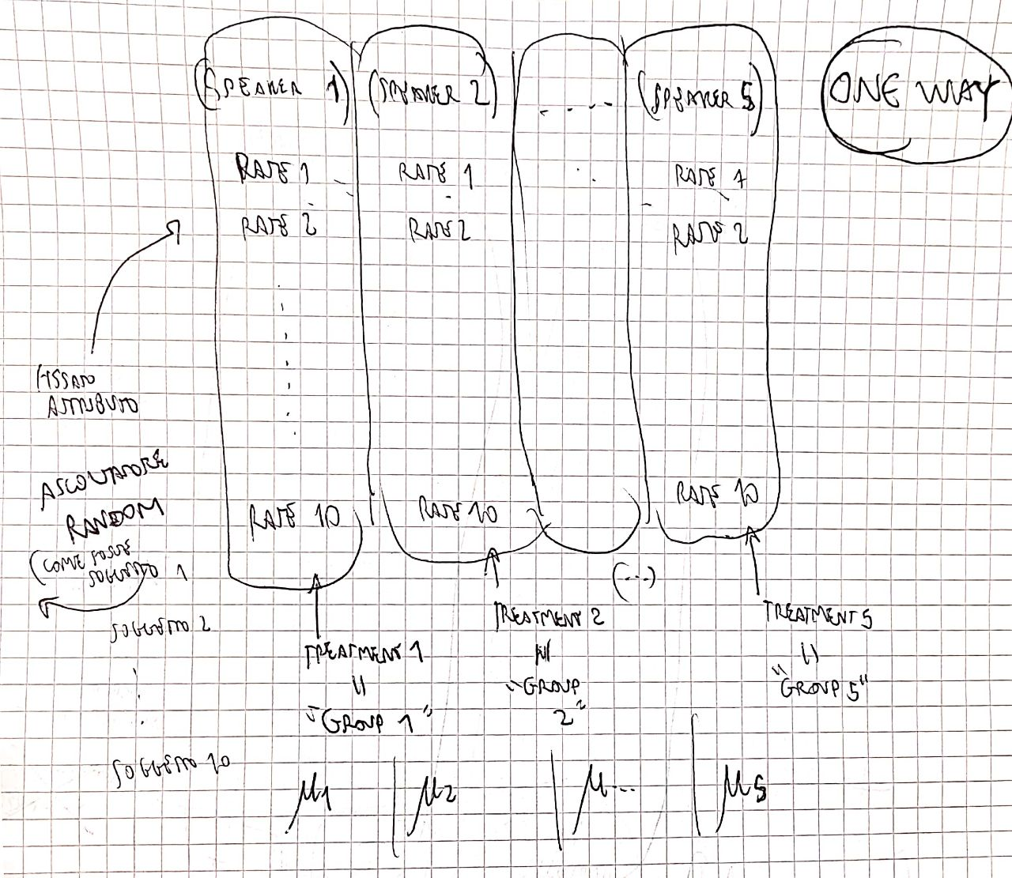
The deviations are calculated as so-called sum of squares (SS) (…) (See “type III error”)
The rationale for testing is the same as that for the t-test: The probability of obtaining F values higher than a specified value can be determined by the F-distribution for a given set of degrees of freedom. The experimenter thus specifies a given test level $α$ (e.g. 5 %) and the obtained Fα value specifies the critical range.
The general principle in the process described above is to divide the total variation in the data set into a number of variance components, which in this case is the ‘between-groups’ and the ‘within-groups’ variance (see Equation 6.58). The variance caused by the treatment (between-groups) is then compared to the error variance (within-groups), and the comparison will show whether the treatment(s) cause(s) a statistically significant change in the response compared to random variation.
(Per capire meglio guarda differenza metriche within group between groups!)
The formal version of this principle can be described by an ANOVA model, which specifies the components responsible for the variation in the data
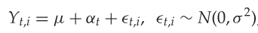
The formulation of the ANOVA model in Equation 6.63 leads to an alternative formulation of the null hypothesis that is often used in statistical texts , in terms of the treatment effects $α_{t}$:
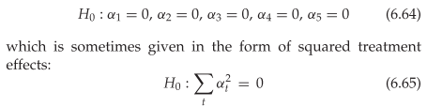
Because $μ_{t}=μ+α_{t}$
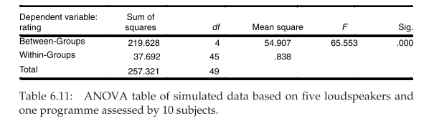
Because $μ_{t}=μ+α_{t}$
$α_{t}$ = between groups
$∈_{t,i}$ = within groups
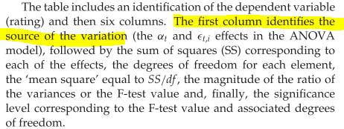
The next step is to identify the pairs with a significant difference in mean values. This could be performed by testing each pair, one by one at a specified significance level, using the stan- dard t-test described in Section 6.2.4.
Analysis of variance compares the means of several groups to test the hypothesis that they are all equal, against the general alternative that they are not all equal. Sometimes this alternative may be too general. You may need information about which pairs of means are significantly different, and which are not. A multiple comparison test can provide this information.
When you perform a simple t-test of one group mean against another, you specify a significance level that determines the cutoff value of the t-statistic. For example, you can specify the value alpha = 0.05 to ensure that when there is no real difference, you will incorrectly find a significant difference no more than 5% of the time. When there are many group means, there are also many pairs to compare. If you applied an ordinary t-test in this situation, the alpha value would apply to each comparison, so the chance of incorrectly finding a significant difference would increase with the number of comparisons (SEE BELOW).
Multiple comparison procedures are designed to provide an upper bound on the probability that any comparison will be incorrectly found significant.
[https://it.mathworks.com/help/stats/multcompare.html]
$→$ BONFERRONI CORRECTION (…)
For larger groups of paired comparisons, the Bonferroni corrected test level becomes very small, so it is better (see for example the discussion in Keppel and Wickens [253] (Section 6.4)) touse Tukey’shonestly significant difference(HSD)
…….
……

$→$ Tukey’s honestly significant difference(HSD) ALSO IN [Moulin2016a
]
IF OUR DATA MEETS THE ASSUMPTION OF HOMOGENEITY OF VARIANCES…………………
The problem, however, is that the specified significance level is only correct for one t-test. If more than one test is conducted, the test level across the entire set of comparisons increases. For example, assume that 100 in significantly different (determined previously) pairs are available and are tested at a 5% significance level. The applied 5% level means that at least five of the tested pairs will erroneously be concluded to be significantly different.
The relationship between the number of comparisons and the corresponding overall Type I error level is formally given by:
$$α_{FW}=1-{\left(1-α\right)}^{c}$$
where $α_{FW}$ is the family-wise Type I error equal to the probability of making at least one Type I error in the family of tests when the null hypothesis is true, $α$ is the Type I error test level for the individual tests and $c$ is the number of tests.
Example: 10 t-tests at 5% level $→$ $1-{\left(1-0.05\right)}^{10}$
The Tukey procedure is based on a critical difference $D_{Tukey}$, which is compared to the observed difference between a pair of means. If the observed difference is larger than $D_{Tukey}$, it follows that the difference is significant at the applied $α$ level. The critical difference is given by:
$$D_{Tukey}=q_{a} x \sqrt{\frac{MS_{R}}{n}}$$
where $q_{a}$ is a quantity that can be found in a table of the Studentised Range statistics, with the entry parameters $a$ equal to the number of pairs to be compared, degrees of freedom for $MS_{R}$ and test level $α$. $MS_{R}$ is the error variance and $n$ is the number of observations for each mean. The Studentised Range statistics is defined and discussed in, for example, Hoaglin et al. [163].
[https://it.mathworks.com/help/stats/multiple-comparisons.html#bum7ugv-1]
The test is based on studentized range distribution. Reject H₀:α_{i} = α_{j} if
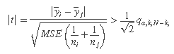
where qα,k,N−k is the upper 100*(1 – α)th percentile of the studentized range distribution with parameter k and N – k degrees of freedom. k is the number of groups (treatments or marginal means) and N is the total number of observations.
Tukey’s honestly significant difference procedure is optimal for balanced one-way ANOVA and similar procedures with equal sample sizes. It has been proven to be conservative for one-way ANOVA with different sample sizes.

DIFF. BETWEEN 1WAY 2WAY [https://www.researchgate.net/post/What_is_the_difference_between_1way_ANOVA_and_2way_ANOVA_and_MANOVA_How_would_I_know_where_to_apply_which_one]
Classic ANOVA is inherently univariate…
ONE WAY/TWO WAY = how many factors can make the mean of what we are finding different (maybe in our case of speakers the rating)
NELL’ESEMPIO DI BECH [bech2006] DELL’ONE WAY E’ LO SPEAKER
One-Way ANOVA: An ANOVA hypothesis tests the difference in population means based on one characteristic or factor. a----->b "An example of when a one-way ANOVA could be used is if you want to determine if there is a difference in the mean height of stalks of three different types of seeds. Since there is more than one mean, you can use a one-way ANOVA since there is only one factor that could be making the heights different. "
Two-Way ANOVA: An ANOVA hypothesis tests comparisons between populations based on multiple characteristics. a---->c<----b "Suppose that there are three different types of seeds, and the possibility that four different types of fertilizer is used, then you would want to use a two-way ANOVA. The mean height of the stalks could be different for a combination of several reasons"
LA DIFFERENZA TRA ONE-WAY E TWO-WAY E’ COSA STO ASSUMENDO ABBIA EFFETTO PER LA VARIABILITA’ DEI MEANS ECC…
(Guarda esempio two-way popcorn se dovessi applicarlo agli speaker)
______________________
Multivariate analysis of variance (MANOVA): it is simply an ANOVA with several dependent variables. That is to say, ANOVA tests for the difference in means between two or more groups, while MANOVA tests for the difference in two or more vectors of means. a----->c, b------>d, a----->d, b----->c
In a one-way ANOVA, the key thing is you ONLY ONE explanatory/ independent variable. How many response/ independent variables available do not matter. For example, you are analysing effect of NPK fertiliser application rates on (1) Yield, (2) Growth, (3) Nutrient content, (4) etc, the number of these response variables do not make it a two-way or multiple ANOVA, it is still a one-way ANOVA on the basis of having one explanatory variable. Also, the number of levels do not determine a 2-way or 1-way ANOVA. You can have 3 or more (less than 3 will be a T-test) levels but will still be one-way as long as there is one factor; NPK application rates in this case.
Therefore, for an ANOVA to be called two-way, its when there are two explanatory variables regardless of how many levels each has. For example, you are assessing the effect of fertiliser application rates and cultivar differences on growth and yield of a particular crop. Here, in addition to fertiliser rates, you have another factor; cultivars. In this case, you have a two-way ANOVA. When they are more than two, say you add different agro-ecological zones, you have a multiple ANOVA. How you approach different ANOVAs depend on the experimental designs, such that in CRD, ANOVA will be different from RCBD. In 3 factors, A split plot experimental design works better and has a different statistical model and hence a different ANOVA.
Its also important to know that a response variable does not have levels, it is incorrect to name them as such, they are simply response variables e.g. growth, yield, nutrient content etc. Levels are used for explanatory variables

1WAY & 2WAY IN THE BECH MODEL
COME SI TRADUCE NEL MODELLO DI BECH DEL LIBRO?
• (univariate)ONE VARIABLE (ONE WAY) ANOVA MODEL
• (univariate)ANOVA MODEL FOR MORE THAN (N-WAY) ONE VARIABLE
Listening tests are conducted using several programmes, and this introduces an additional treatment variable in the ANOVA model, accounting for the variation caused by the different programmes:
PRATICAMENTE NEL CASO TWO WAY
AGGIUNGO $β_{j}$ CHE E’ UN ALTRO EFFETTO ANCORA NELLA POSSIBILE VARIAZIONE DEL MEAN
IN GENERALE PER N-WAY

DIFF BEWTWEEN UNIVARIATE/MULTIVARIATE [https://www.researchgate.net/post/Difference_between_One_Way_ANOVA_and_Univariate_Analsysis]
When referring to "univariate" statistical methods, most folks are describing the number of dependent (outcome) variables involved in a data analysis: one. A multivariate statistical method implies two or more dependent variables.
AD ESEMPIO IL SUBJECTIVE RATING Y_i,t E’ UNIVARIATE SIA NEL CASO CHE E’ ONE WAY (primo esempio [bech2006]) SIA NEL CASO CHE TWO WAY (O OLTRE) (secondo esempio [bech2006]).
il subjective rating $Y_{i,t}$ -> univariate
piu fattori tipo
multipli attributi
e speaker/soggetti -> two way
One-way anova has a single independent variable (IV which is categorical/nominal, as you indicate) having two or more levels, and a single, metric (DV, interval or ratio strength scale) dependent variable. One-way manova has a single IV and two or more metric DVs

••UNDERSTAND TWO-WAY WITH THE FRAMING OF DATA AND UNDERLYING MODEL IN [bech2006]
AA
http://people.stern.nyu.edu/jsimonof/classes/2301/pdf/anova2.pdf
$↑$ $↑$

[Science2010]

implementation of a 2-way in matlab
https://it.mathworks.com/help/stats/anova2.html (matlab comprises interactions)
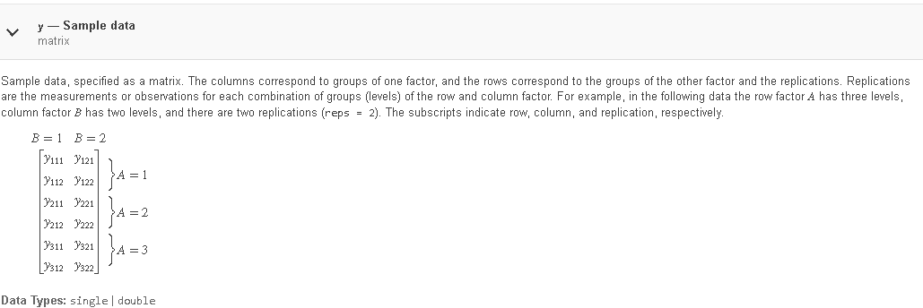

TERMINOLOGY
factor = way (one,two, N ecc…)
DOING THIS CORRESPONDS TO INTRODUCE AN INTERACTION TERM
IF ONE WANT TO TEST THAT INTERACTION!!

••UNDERSTAND MIXED AND FIXED (generic a cavallo tra le cose sopra)
SICCOME “group means are distributed around the overall mean for ALL 40 observation” (SEE F-VALUE OTHER DOCUMENT) ALLORA I RANDOM FACTORS SONO
traccia i
speaker j
NELL’ESEMPIO DELLA MIA ONE WAY CHE HO FATTO?

[Moulin2016a]
• an univariate ANOVA was performed for each elicited attribute using a mixed model [21], considering "Repetition" and "Assessor" as random factors, and "Loudspeaker" and "Track" as fixed factors.
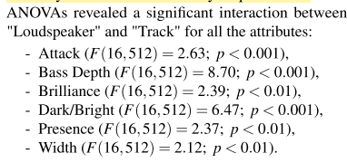
•The residuals were checked and they fulfilled the normality requirements.
•A Tukey HSD (Honest Significant Difference) test was also performed on the loudspeakers for each track and each attribute. This analysis confirmed the presence of significant differences (p < 0.05) between at least 2 groups of loudspeakers for all the tracks, for the at- tributes Bass Depth, Brilliance, Dark/Bright, and Presence (see Table 3). This
Praticamente ogni Colonna (?)

